**Concordia University**

**Department of Computer Science**

**and Software Engineering**

**Software Process**

**SOEN 341/4 --- Winter 2016 --- Section S**

**Deliverable 0**

**January 13th, 2016**

|  |
| --- |
| **TEAM MEMBERS** |
| **Liuai Hatter** |
| **Anna Rogozin** |
| **Gibran Khan** |
| **Wahab Ahmed** |
| **Ricardo Contés** |
| **Jian Huang** |
| **Sabrina Ashraff** |
| **Rami Sandouk** |
| **Philippe Abou Kasm** |
| **Francis Bouchard** |
| **Matthew Teolis** |
| **Clozzy-Mailey Chavez** |

**1.SYSTEM OVERVIEW**

**Name of the system:** Apollo

**Description**

The purpose of this system is for a student enrolled in the Software Engineering program to plan their schedule for the entire duration of the program. The application will have students in the program as its class of users. With this application, a student will be able to define their program option in Software Engineering, whether it be General, Computer Games, Web Applications, or Real-Time and Embedded Systems. Once that is defined, a master course list will be provided with all the courses the student is required to take. From there, a student will be able to select the courses they wish to take each semester. Additionally, the suggested course sequence for each option provided by the department will also be available, allowing the student to construct their schedule based on the fixed course sequence. The student will also have the option of selecting their preference based on the timing, whether they prefer morning, afternoon, or evening classes. Once all these preferences are selected by the student, the Apollo application will evaluate the academic record of the student, and check if each course’s prerequisites have been met, if the credit requirements are present, and courses for which the student has an exemption. Additionally, Apollo will assure to select courses in which the professor is an accredited engineer as is required by the Software Engineering program. Once all these checks have been made, Apollo will generate the number of possible schedules that the student can choose from, and the student can then select the schedule they prefer

**Domain Model-Description**

The domain model consists of the following domain classes. The Login domain class will store the student ID and password. The Student domain class will store the student ID and their name/username. The Master Course List domain class will consist of a master list of all the courses in the program. The Courses domain class will contain the number of a single course, the course name, the course section, the department the course belongs to, the prerequisites required for the course, the professor giving the course, and the semester in which the course is available. The Academic Record domain class will contain the courses already taken, the grades received for each completed course, the program the student is registered in, including the option selected, and the exemptions they have received from any course. The Scheduler domain class will plan the schedule, taking into account preferences, courses selected, and prerequisites that are required. The Preferences domain class will store the preferences selected by the student. The Schedule domain class will generate the schedules based on the information form the scheduler.

There will be a one to one association between the Student and Login, one login available per student and one student associated to each login. There will be a one to one association between Student and Master Course List, one list of courses available for each student. The will be one Student associated with one to many Courses, as one student can select many courses. There will be a one to one association between Student and Academic Record, one record available per student. There will be one Student with 0 to many Preferences, as a student can select many preferences for their schedule. For one Student there can be 0 to many Schedules, as, based on the preferences set by the student, Apollo can generate any number of schedules depending on if it is possible. For one Master Course List, there is 1 to many courses available, as the Master Course List is a list of all courses available in the program. Between the Scheduler and Courses, there is 1 to many courses available to the scheduler depending on what the student selects. Between the Scheduler and Academic Record, there is a one to one relationship as for one scheduler there is one academic record available. For one Scheduler, there are one to many Preferences available. Lastly, there is one Scheduler for one to many Schedules, as based on the scheduler many schedules can be generated.

**Domain Model-Diagram**

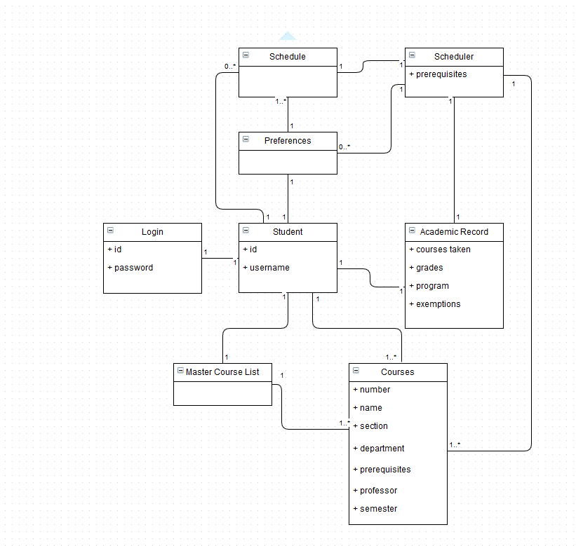

**2.TEAM MEMBERS**

**Name of the Team:** Athena

**Team Leader:** Liuai Hatter

**Git Repository:** <https://github.com/ApolloSoen341>

**Team Members and Tentative Proposed Roles**

**Liuai Hatter-** Programming

**Anna Rogozin-**Programming

**Gibran Khan-**Programming

**Wahab Ahmed-**Documentation

**Ricardo Contés-**Documentation

**Jian Huang-**Programming

**Sabrina Ashraff-**Documentation/Testing

**Rami Sandouk –**Documentation/Testing

**Philippe Abou Kasm-**Documentation

**Francis Bouchard-**Programming

**Matthew Teolis –**Programming

**Clozzy-Mailey Chavez-**Documentation